Tools and Contact Details:
- Illustrations: Mr.Bharat Rai (Illustrator), email: phoenixesare@gmail.com
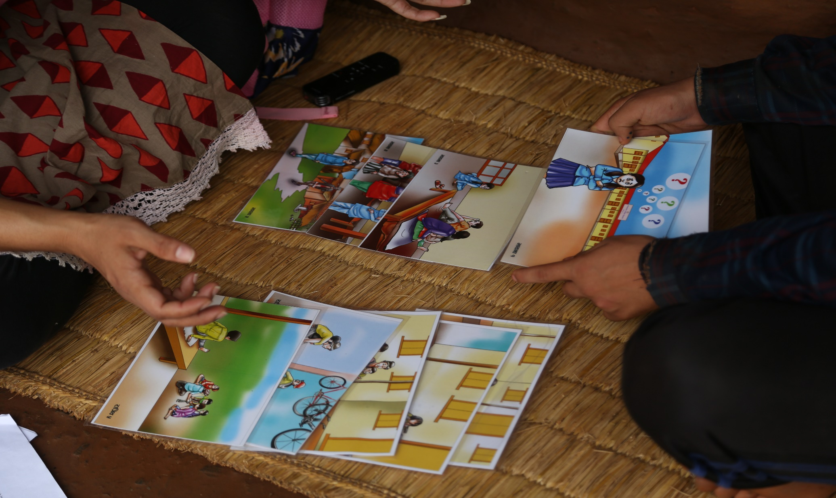

- Dolls: BODHI CRAFTS, Kupondole Lalitpur, Nepal. Phone:9849806206
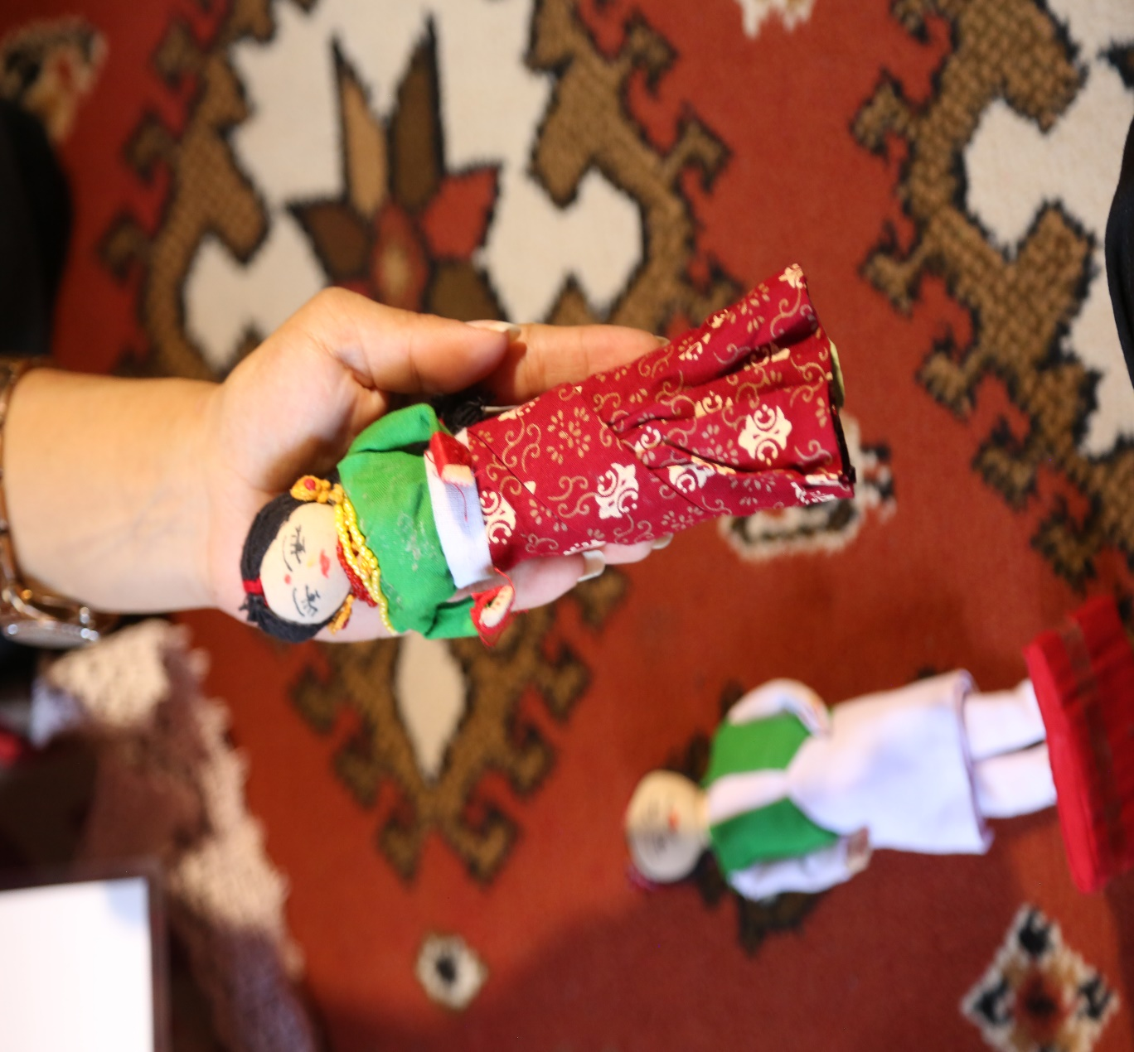

- Dice: BODHI CRAFTS, Kupondole Lalitpur, Nepal. Phone:9849806206
